COMPLIANCE AND INDEMNITY AGREEMENT

BETWEEN:
ALBERTA RUGBY FOOTBALL UNION
11759 Groat Road
Edmonton, AB
T5M 3K6
(Hereinafter “Rugby Alberta”)

- And -

Cold Lake Penguins RFC
6160 Stn Forces
Cold Lake, AB
T9M 2C1
(Hereinafter the “Club”)

The Parties have agreed to enter into an agreement concerning the Club’s compliance with Rugby Alberta’s Return to Play Guidelines and wish to reflect the terms of their agreement in writing;

NOW THEREFORE, the Parties hereby agree as follows:

Acknowledgement
- The Parties acknowledge that the Club has been provided with Alberta Rugby’s Return to Play Guidelines, which are alternately titled Modified Phase Programming (COVID-19 Contingency Plan), and which describe communication strategies and phases of return to play.

- The Parties acknowledge that the Return to Play Guidelines are a ‘living document’ and updates to the document will be provided by Alberta Rugby to the Club whenever they occur.

- The Parties acknowledge that the Club is responsible for maintaining an updated, current version of the Return to Play Guidelines.

Compliance
- The Club agrees that they will comply with the directions and requirements of the Return to Play Guidelines.

Liability and Indemnity
- The Club will indemnify and hold harmless the Rugby Alberta, Calgary Rugby Union, Edmonton Rugby Union and its directors, officers, consultants, agents and employees (“Rugby Alberta Indemnified Parties”) from and against any and all loss of, or damage to, property, or injuries to, or death of, any person or persons and will defend, indemnify and hold harmless the Rugby Alberta Indemnified Parties, or any of them, from any and all claims, damages, suits, costs, expenses, liabilities, fines, obligations, penalties, demands, actions or proceedings of any nature or kind whatsoever (including, without limitation, legal fees and disbursements) of or by anyone whosoever, resulting from, or arising out of, directly or indirectly:
- Any negligent act or omission or wilful misconduct of the Club or its directors, officers, servants, subcontractors, employees or any other persons for whom in law the Club is responsible who are acting under the Club’s direction or supervision;
- Failure by the Club to follow the Return to Play Guidelines; or
- Any breach of any term, obligation, requirement, covenant or condition of this Agreement on the part of the Club.

- The provisions of the above clause will continue in force indefinitely after termination of this Agreement.
Term
- This Agreement will commence on 11 July 2020 and will continue indefinitely until terminated pursuant to this Agreement.

Termination of Agreement
- Alberta Rugby may terminate this Agreement immediately upon written notice to the Club of its intention to terminate this Agreement, which will terminate accordingly.

Notices
- Notices and correspondence required to be sent to any party in connection with this Agreement will be in writing and will be sent by post to the addresses listed above. Any change in address will be notified to the other party immediately. Notice will be deemed to have been given after the seventh day of the date of post for mail and the day of delivery for hand-delivery, facsimile or email.

Governing Law
- This Agreement will be interpreted in accordance with the laws of the Province of Alberta.

General
- The Parties have sought or obtained, or have had the opportunity to seek and obtain, independent legal advice concerning the matters in this Agreement, and execute this Agreement knowingly and voluntarily.

- This Agreement has been executed by an authorized signatory of each Party who is duly entitled to represent and bind the Party.

- The termination of this Agreement, for whatever reason, will not terminate any provision which is expressly provided to continue in force after such termination.

THE PARTIES HEREBY AGREE to abide by the terms and conditions outlined in this Agreement.

RUGBY ALBERTA

_______________________________ _________________________ _______________
Name, position (print) Signature Date

CLUB

Sean Verheyde, President____________ 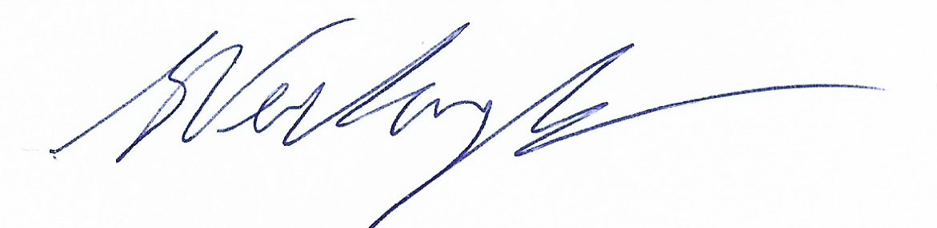 11 July 2020_____
Name, position (print) Signature Date

